Cafeteria Rules

These are our cafeteria rules that all students follow.

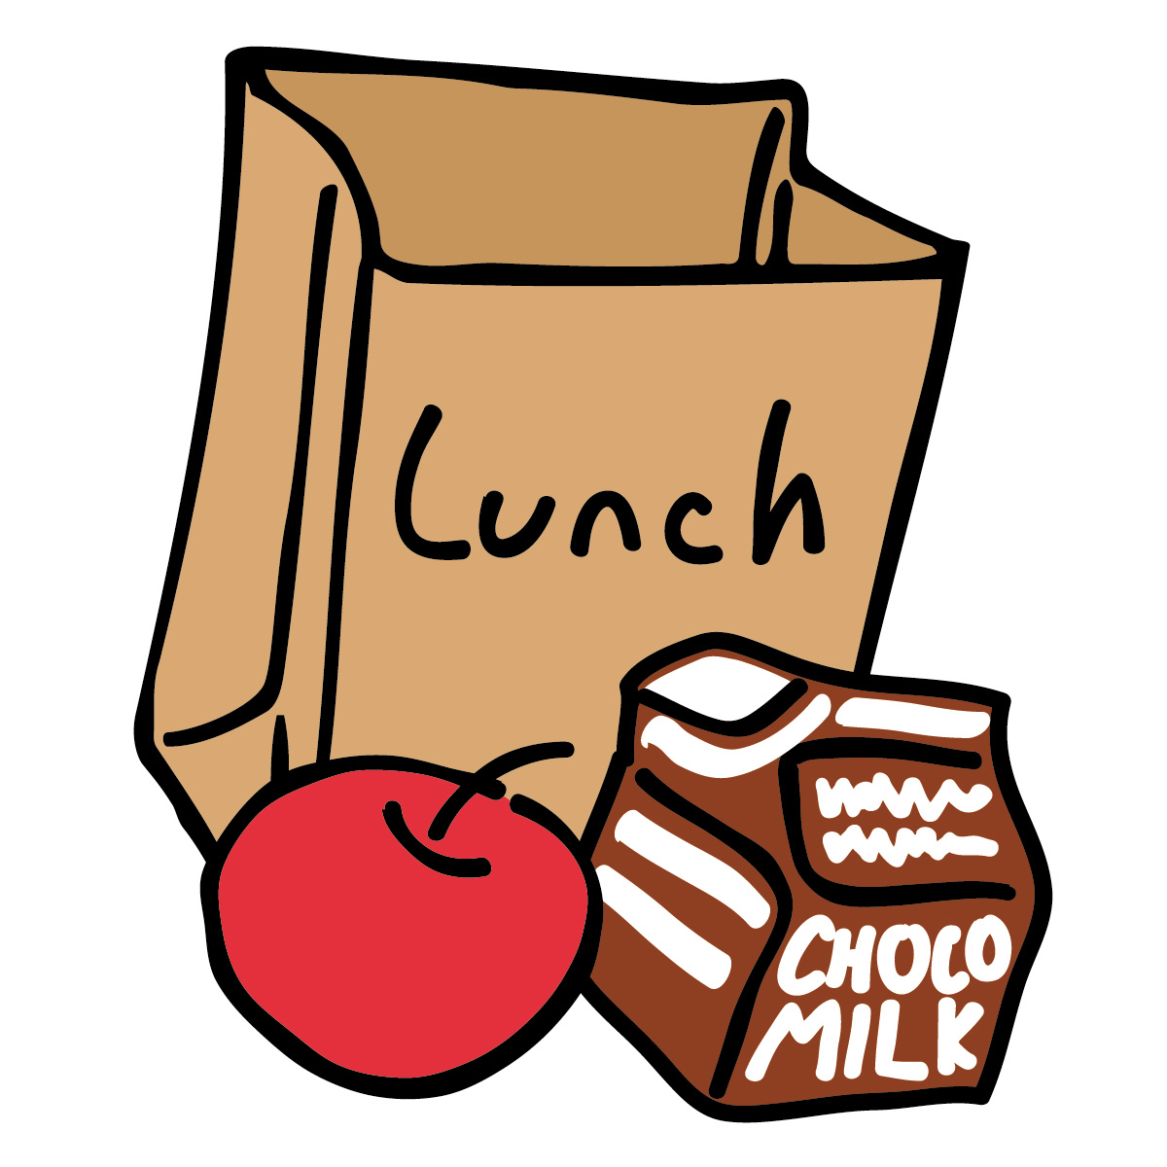
- No Talking when music is playing!
- Remain quiet in the serving line
- Receive permission to get up from the table
- Talk quietly to only those at your table
- Leave tables and floor clean
- One table at a time will be dismissed
- Use good table manners when you eat

Thanks for helping us follow these rules!

Playground Expectations for Claxton & ACES

The playground at Claxton will be a safe place where positive sportsmanship is displayed.

Expectation #1

Equipment will be used appropriately.
- Monkey Bars- Monkey bars were made to build upper body strength. You may not walk across the top or sit on the monkey bars.
- Slides- Go down the slide on your bottom with your feet facing forward, one person at a time.
- Rock Wall- Climb up and down the rock wall; you may not jump off or pull others down from it.

Expectation #2

Positive sportsmanship will always be displayed without any ‘rough play’.
- Rough play is not permitted- hitting, shoving, pushing or pulling in any game or otherwise.
- Conversations should always be pleasant without any name calling, threats or accusations.

Expectation #3
Our playground will be kept clean and safe.

Rocks, mulch and acorns stay where they belong. You may not throw or move any of these items.
- Pick up any litter from lunch or snacks and throw away in outdoor trash cans, or plastic bags brought from class.
- P.E. equipment will not be kicked or thrown into retention pond, if possible. Play with equipment away from the pond to decrease the likelihood of this happening.
- Please do not chase or go near the geese.

Hall Way and Breezeway Expectations

- Hallways and Breezeways are quiet zones.
- Walk, not run, in the hallways and breezeways.
- Walk on the right side of the hallway.

